Taylor Building Window Concern

# **Explanation**

There is a security concern regarding the Psalm 15 Walkway on the side of Taylor building. Some could easily access one of the building windows by following these steps:

1. From the top, left side of the stairs, stepping up to the wall.
2. Walking across the wall and stepping to the connecting overhang.
3. Walking across the overhang to the wall of Taylor building.
4. Using the closeness of the overhang and the window of Taylor building to access the window.

The image and text below show the exact spot described and visually depicts each step. Each step also includes a verbal explanation for clarity.

# **Visual**

1) This arrow marked by an orange line, points out how easy it is to access the wall.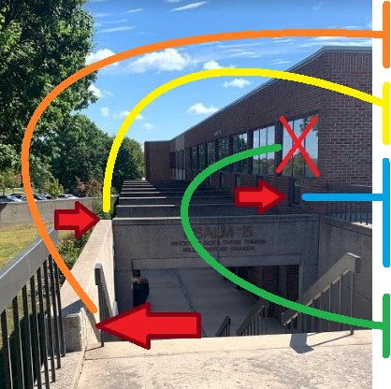

2) This arrow marked by a yellow line shows where the two overhangs connect.

3) The overhang marked by a blue line shows where the second overhang meets the wall of the Taylor building. This is very close to the window in question.

4) The green line shows how easy it would be to access the window of concern.

# 

# **Conclusion**

This is a security risk for SBU. Anyone could follow these steps to access the building. This does assume that the window is unlocked or the intruder intends to break the window. However, either of these are likely in the case of someone wanting to break in. This needs to be addressed immediately.